

**@STANFORD**

**Mobile Application Development (MAD2009MA)**

**MAD 400-75 iOS Development**

**Assignment1 – 18% Marks**

**Prepared By: Submitted To:**

**Damanpreet kaur Prof. Rajesh Khanna**

**Mandeep Kaur**

**Rohit verma**

**Student Id: A00107506**

**Student Id: A00107544**

**Student Id: A00107533**

**Date: 15-03-2020**

Table of Contents

Installation of Xcode: 2

A technical document regarding Xcode: 4

Introduction to Xcode: 5

Capabilities of Xcode: 6

Use and explore the Xcode interface: 6

Xcode Screenshot: 8

Tab Bar 8

Options 9

Editor 9

Help Option 10

Reference 11

s

# Installation of Xcode:

Firstly download xcode from aap store.

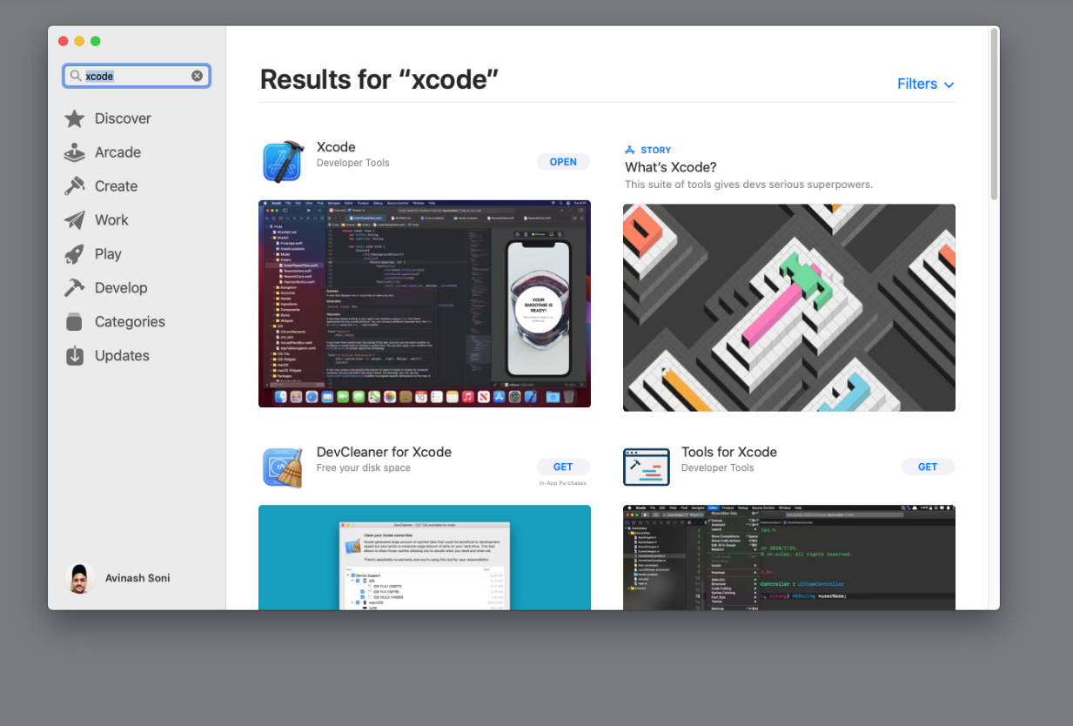

Then simply open Xcode.

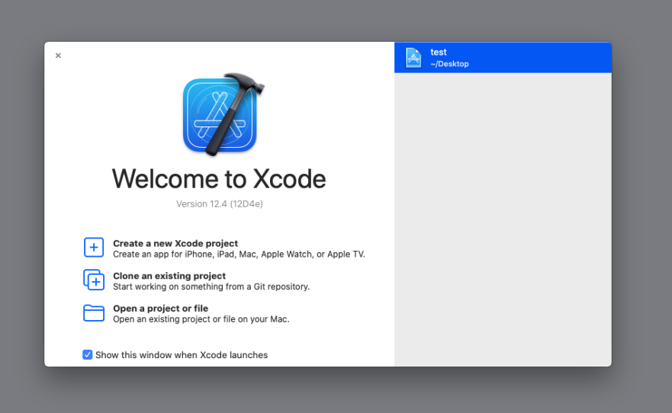

# A technical document regarding Xcode:

Xcode can dispatch its advancement apparatuses, otherwise you can dispatch them freely from the Xcode > Open Designer Apparatus menu: Use Test system for fast prototyping and testing your app in a reenacted environment when a genuine gadget isn't accessible. Test system gives situations for iPhone, iPad, Apple Observe, and Apple TV gadgets with diverse settings, records, and working framework forms. For more data, see Test system Help. Use Rebellious to profile and analyze your app, progress execution, and discover memory issues. Rebellious collects information and presents the comes about utilizing distinctive devices called disobedient. For more data, see Instruments Help. Use Make ML to make and prepare custom machine learning models for your app. See Make ML for more information. Use Reality Composer to build 3D compositions and expanded reality (AR) encounters. See making 3D Substance with Reality Composer for more data.

# Introduction to Xcode:

Xcode is Apple’s coordinates advancement environment (IDE) that you just utilize to construct apps for Apple items counting the iPad, iPhone, Apple Observe, and Mac. Xcode gives devices to oversee your whole improvement workflow—from making your app, to testing, optimizing, and submitting it to the App Store.

Xcode bolsters source code for the programming dialects C, C++, Objective-C, Objective-C++, Java, AppleScript, Python, Ruby, ResEdit (Rez), and Quick, with an assortment of programming models, counting but not constrained to Cocoa, Carbon, and Java. Third parties have included bolster for GNU Pascal, [6] Free Pascal, [7] Ada, [8] C#, [9] Go,[10] Perl,[11] and D.[12] Xcode can construct fat double records containing code for different designs with the Mach-O executable arrange. These are called widespread parallel records, which permit computer program to run on both PowerPC and Intel-based (x86) stages which can incorporate both 32-bit and 64-bit code for both models. Utilizing the iOS SDK, Xcode can moreover be utilized to compile and investigate applications for iOS that run on ARM design processors.

# Capabilities of Xcode:

A capability gifts your app get to to an app benefit given by Apple, such as Cloud Kit, Amusement Center, or In-App Buy. To utilize a few app administrations, you must arrangement your app, including a capability with Xcode's venture editor that designs the app benefit accurately for you. Xcode alters the Privileges and Data Property List records, includes related systems, and arranges you’re marking assets. However, a few app services—such as Diversion Center and In-App Purchase—require extra setup in App Store Interface and your engineer account. For illustration, you would like to transfer a geographic scope record utilizing App Store Interface for an app that employments Maps to supply bearings for other apps.

The stage, and whether you are a part of the Apple Engineer Program, may restrain the capabilities accessible to your app. For the bolstered capabilities, go to the Reference segment of Engineer Account Help—for illustration, go to Bolstered capabilities (iOS) for the capabilities accessible to iOS apps. Before you start, include your Apple ID account and allot the extend to a group so that Xcode can arrangement your app. For iOS, tv OS, and watch OS apps, run your app on a gadget to enlist a gadget and make a advancement provisioning profile.

# Use and explore the Xcode interface:

John Beam presents you to Interface Builder: the momentous client interface editor coordinates into Xcode. Interface Builder gives a visual approach to application interface plan that's fun, natural, and misleadingly powerful.

In spite of the fact that these are certainly imperative aptitudes for getting to be a effective designer, there’s nothing very like laying out your to begin with iOS application interface and observing it come to life in your hands. This hour presents you to Interface Builder: the exceptional client interface editor coordinates into Xcode. Interface Builder gives a visual approach to application interface plan that's fun, natural, and misleadingly powerful. Interface Builder (or IB for brief) does assist you make interfacing for your applications, but it isn’t a fair a drawing device for GUIs; it makes a difference you typically construct application usefulness without composing code. This interprets to less bugs, less advancement time, and easier-to-maintain projects. If you perused through Apple’s designer documentation, you’ll see Interface Builder alluded to as an “editor” within Xcode. This is often a bit of an oversimplification of an apparatus that already existed as a standalone application within the Apple Designer Suite. An understanding of IB and its use is as in a general sense vital to iOS advancement as Objective-C. Without Interface Builder, making the foremost fundamental intuitively applications would be a work out in frustration.

# Xcode Screenshot:

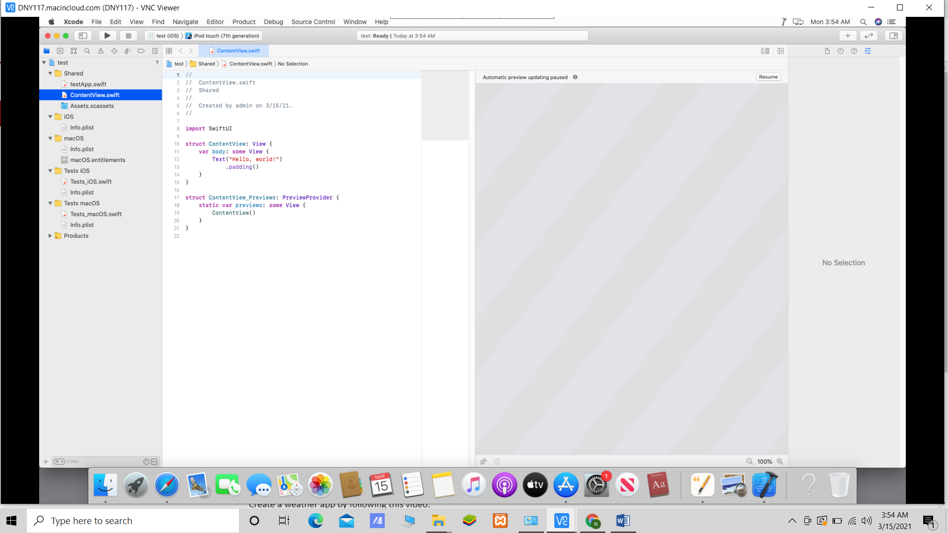

# Tab Bar

A tab bar is generally a bottom bar which is allocated in apps. It is basically used to hold other features of the application. There are different types to tab bar and the controllers, it based on application that which type of application it is.

* Declaration :- class : “UITabBarController : UIViewController”

# Options

There are lot of options and tools in the Xcode but now we are going to talk about top options that are present in Xcode and these are following:

1. File
2. Edit
3. View
4. Find
5. Navigate
6. Editor
7. Product
8. Debug
9. Source Control
10. Window
11. Help



# Editor

It is a tool under tool bar used edit the application. It has various tools we can see in the image shown below.

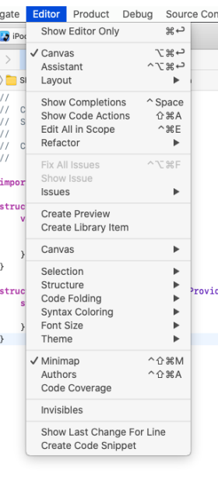

# Help Option

We can access quick help from this option in Xcode.

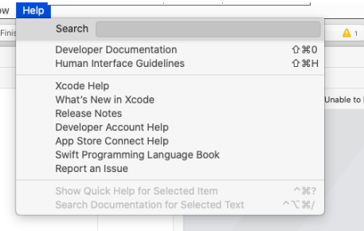

# Reference

<www.google.com>